Dilay Selim
Exercises in Multimedia Web Design
INTRODUCTION TO JAVASCRIPT (Week 9)
Fetch API & DOM Deep Dive

Exercise 6.5 — Comments viewer with status handling
Use the JSONPlaceholder comments endpoint:
https://jsonplaceholder.typicode.com/comments?postId=1

Write an async function loadComments(postId) that:
1. Fetches comments for the given postId.
2. Checks response.ok and throws a custom error if it fails.
3. Renders each comment as a <li> showing: name — email
4. Displays a count: "5 comments loaded" in the <h1 id="title">.
5. Shows an error message in the list if the fetch fails.
6. Call the function with postId 1 when the page loads.

Bonus: Add three buttons (Post 1, Post 2, Post 3). Each button calls
loadComments() with its postId, replacing the current list.

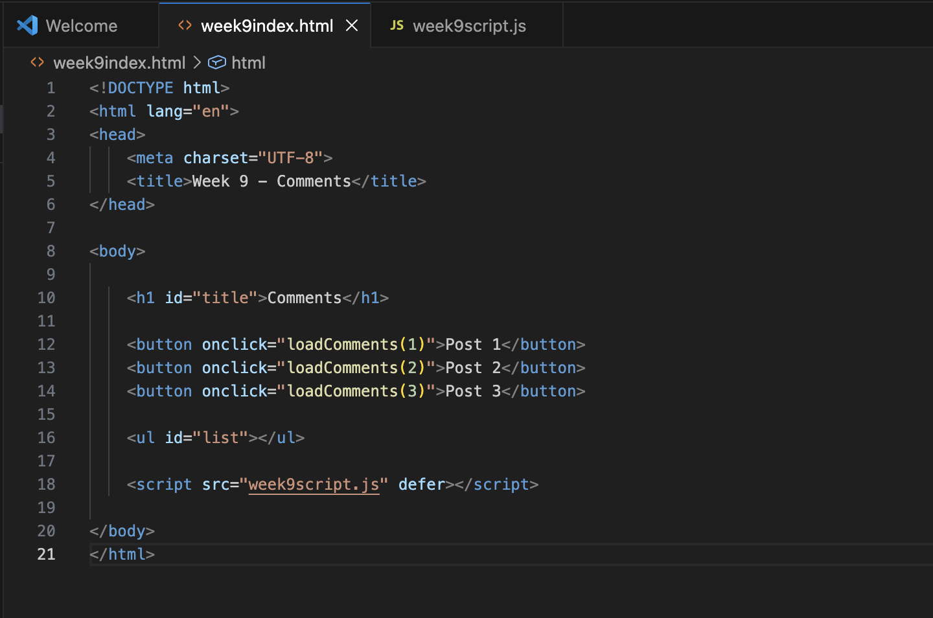

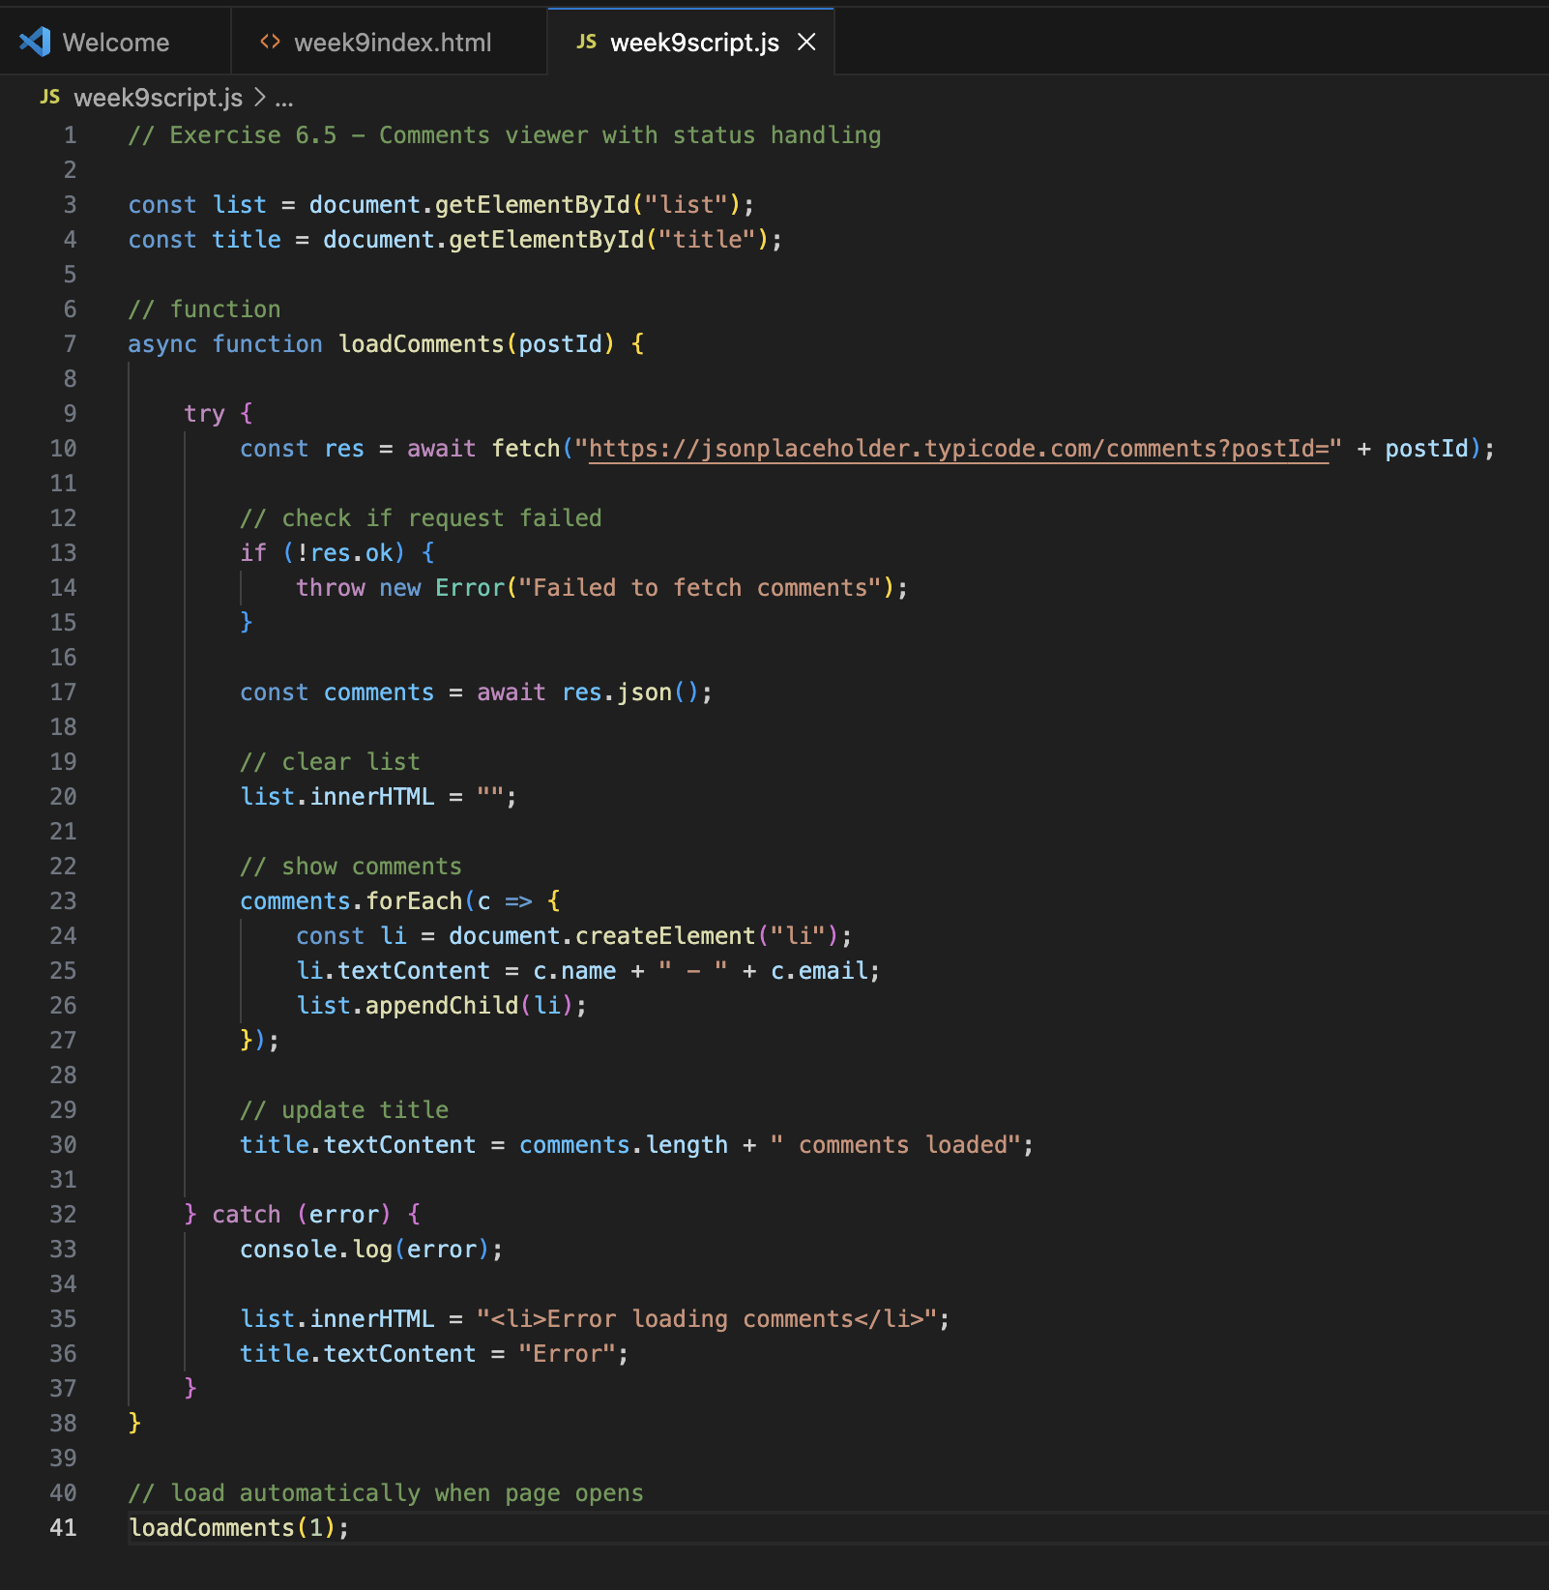

Output:
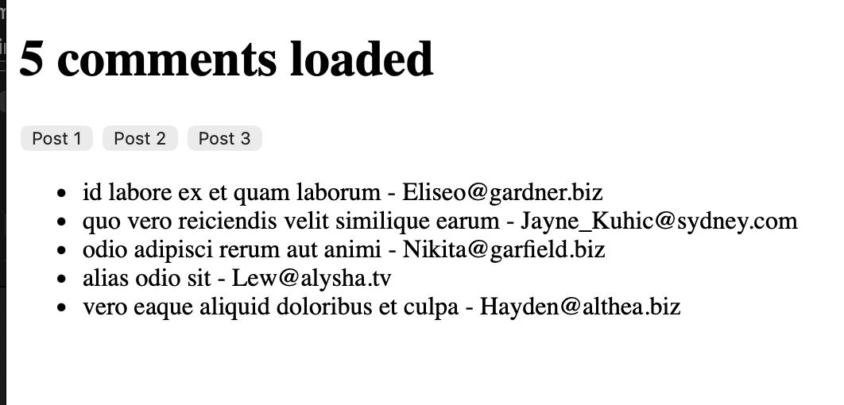

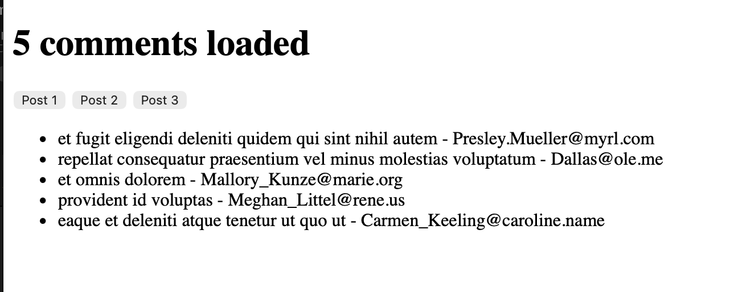

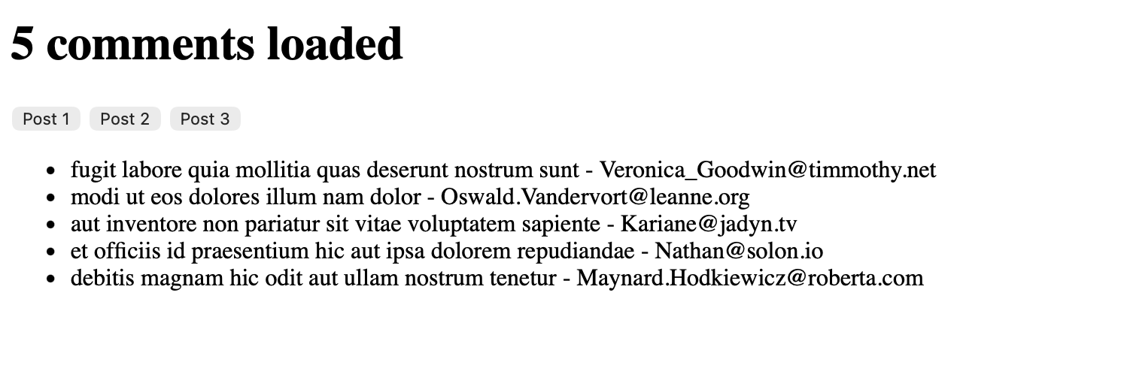

Exercise 7.5 — Interactive photo gallery
Use the JSONPlaceholder photos endpoint (returns 5000 photos):
https://jsonplaceholder.typicode.com/photos?albumId=1

Write JavaScript that:
1. Fetches all photos from albumId 1 (50 results).
2. Creates a <li> for each photo displaying its title.
3. Adds a data-url attribute to each <li> with the photo's thumbnailUrl.
4. Uses event delegation on the list: clicking a photo title logs its
thumbnail URL to the console using e.target.dataset.url.
5. Updates the <h1> to show "Album 1 — 50 Photos".

Bonus: Instead of logging the URL, create an <img> element and append it
to <p id="output"> each time a photo is clicked, so the thumbnail appears.

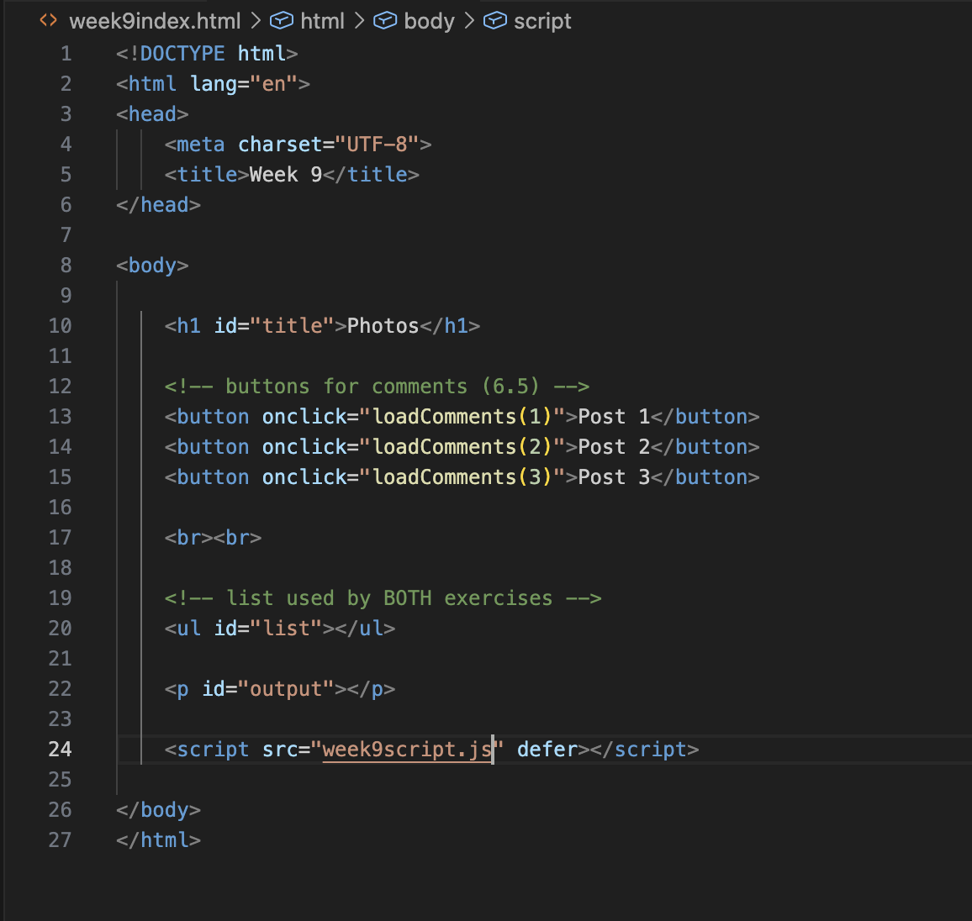

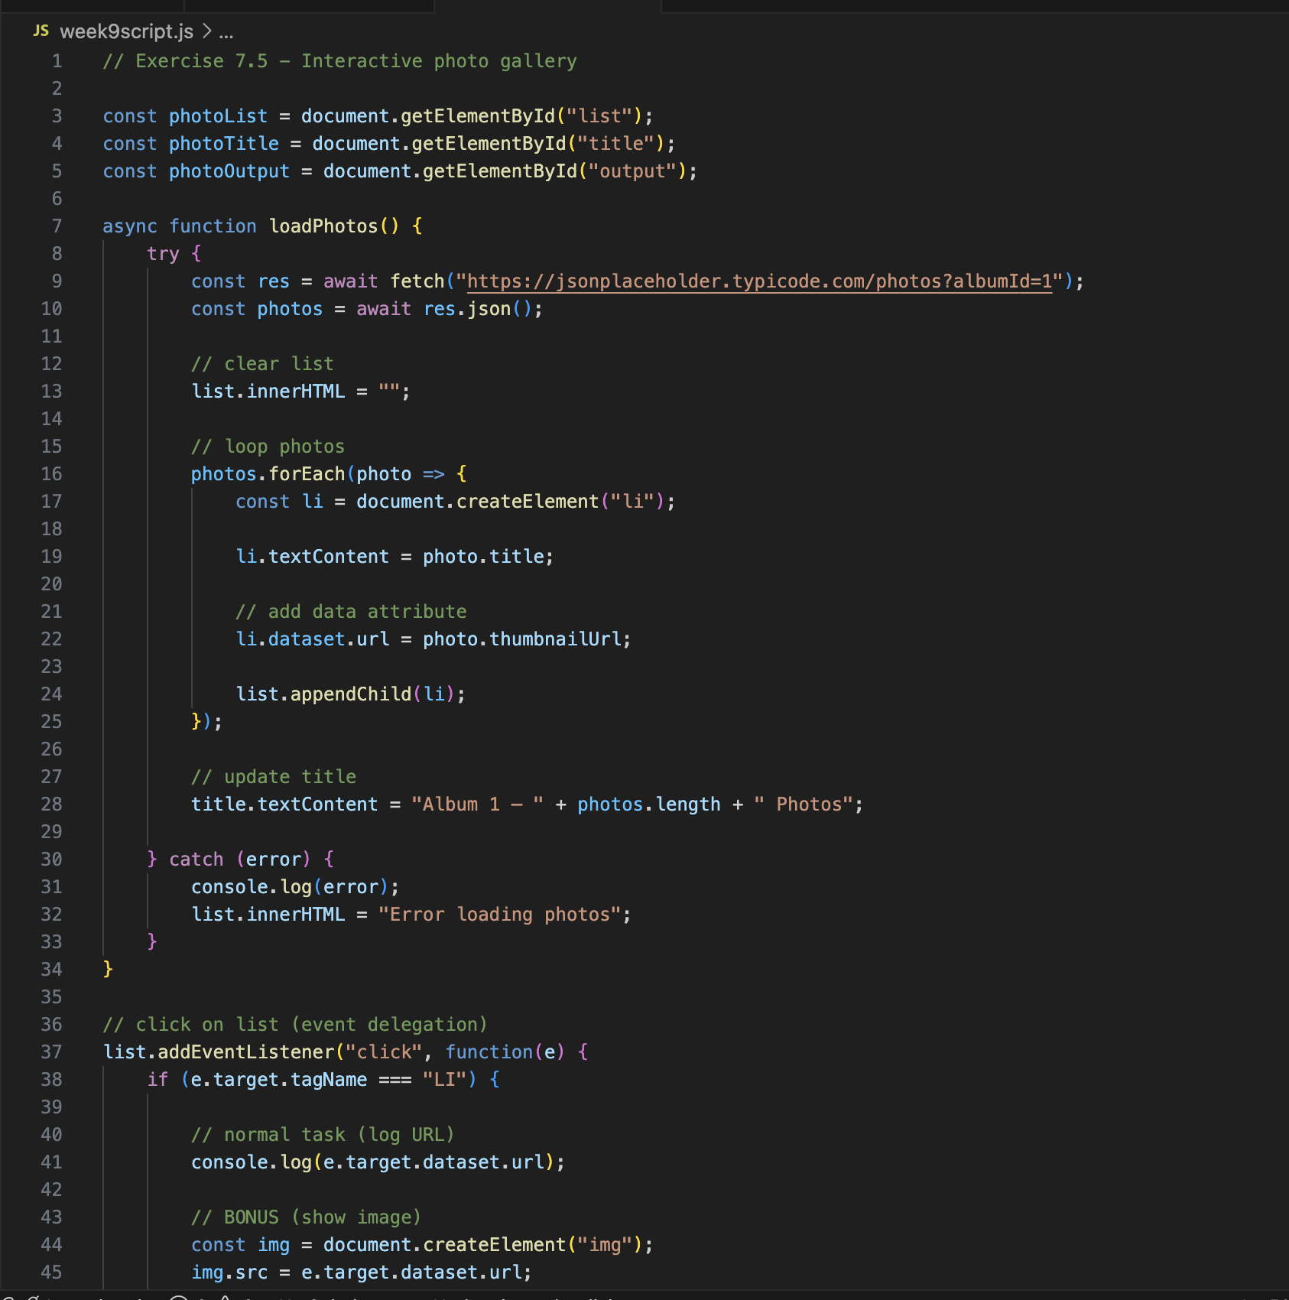
Output:
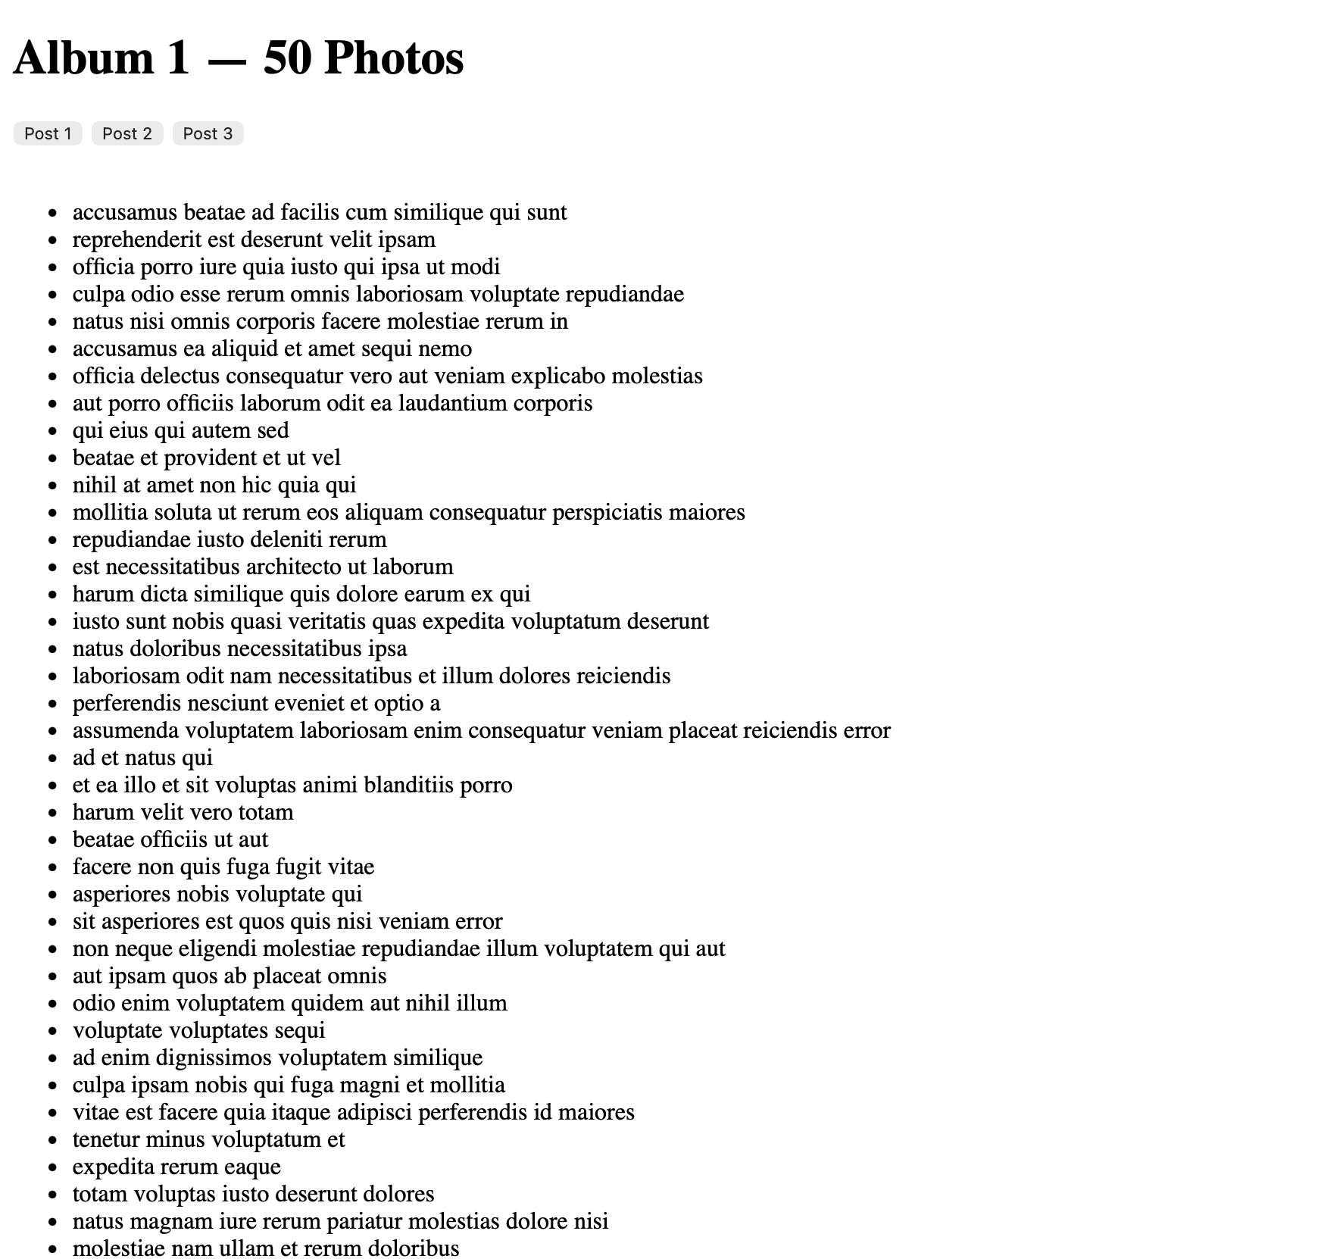

Exercise 8.5 — API inspector
Use the REST Countries API (no auth required):
https://restcountries.com/v3.1/region/europe?fields=name,capital,population

Write an async function exploreAPI() that:
1. Fetches all European countries from the endpoint above.
2. Logs the response status code and content-type header.
3. Parses the JSON and logs how many countries were returned.
4. Uses filter() to keep only countries with population > 5,000,000.
5. Uses map() to extract just the common name: country.name.common.
6. Renders the filtered country names as <li> items in the DOM.
7. Wraps everything in try/catch with a response.ok check.
Bonus: Sort the countries alphabetically before rendering using .sort().
Bonus: Add a URLSearchParams object and log the full constructed URL.
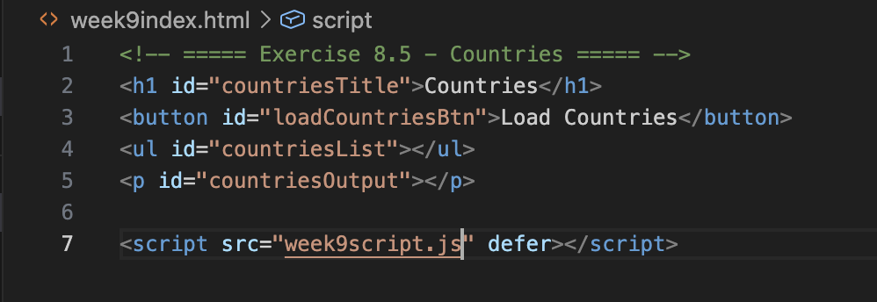
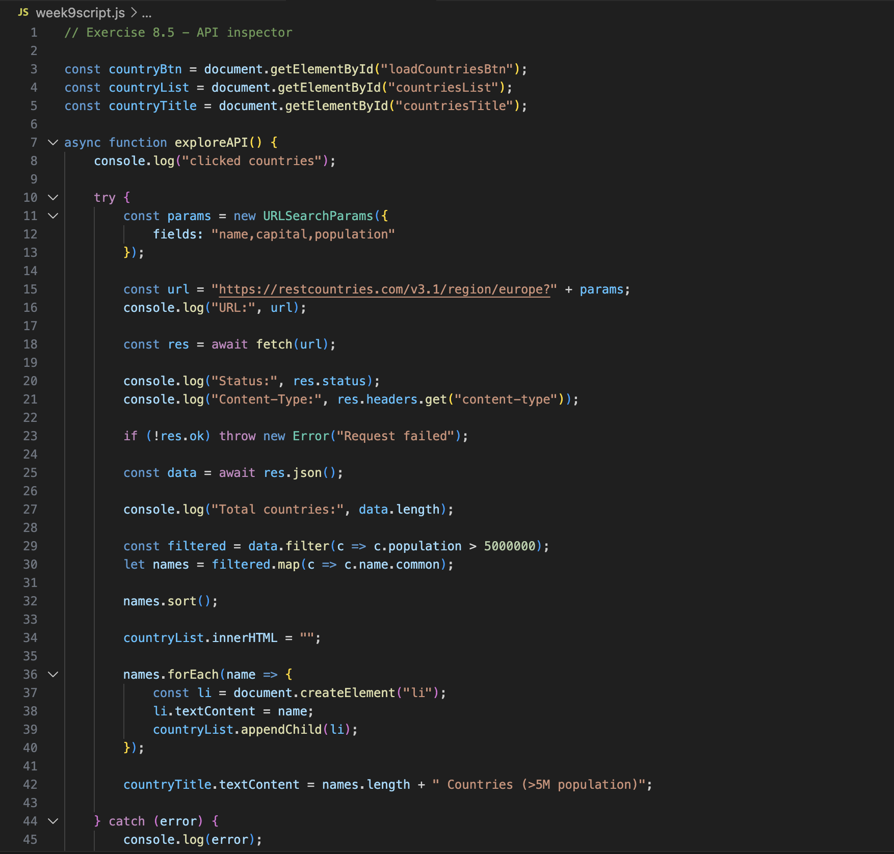

Output:
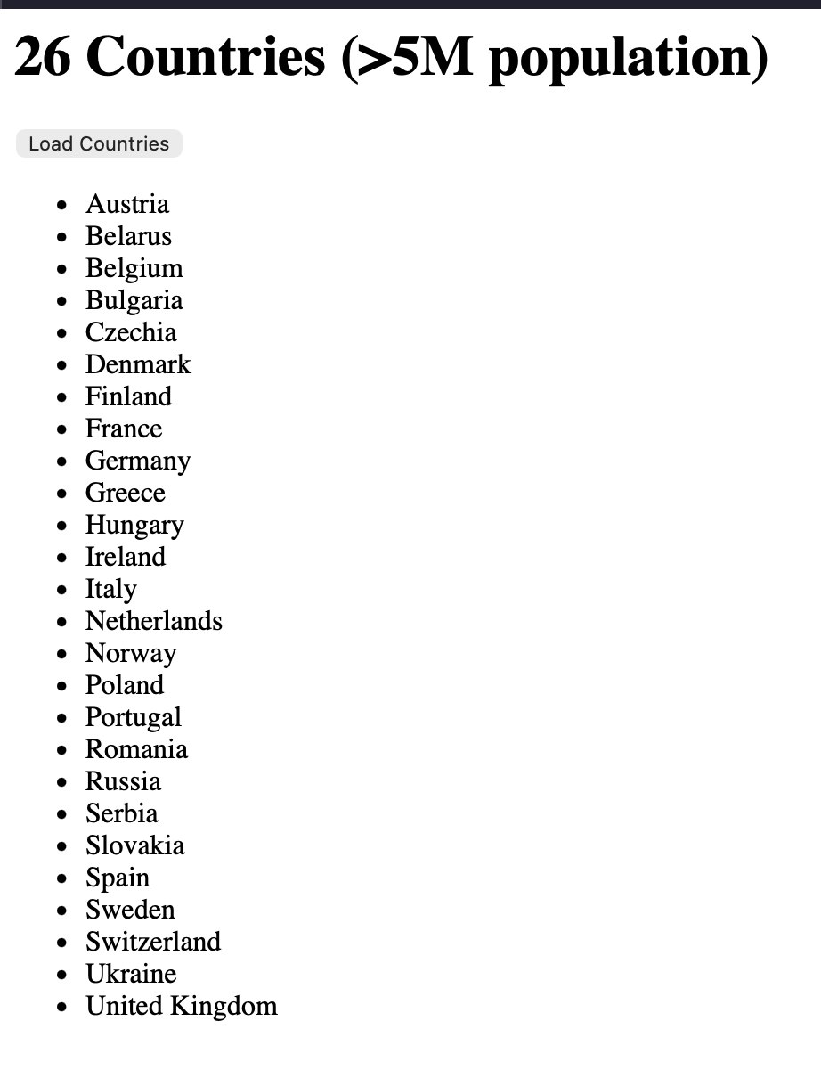
Exercise 9.5 — Vanilla to React translation
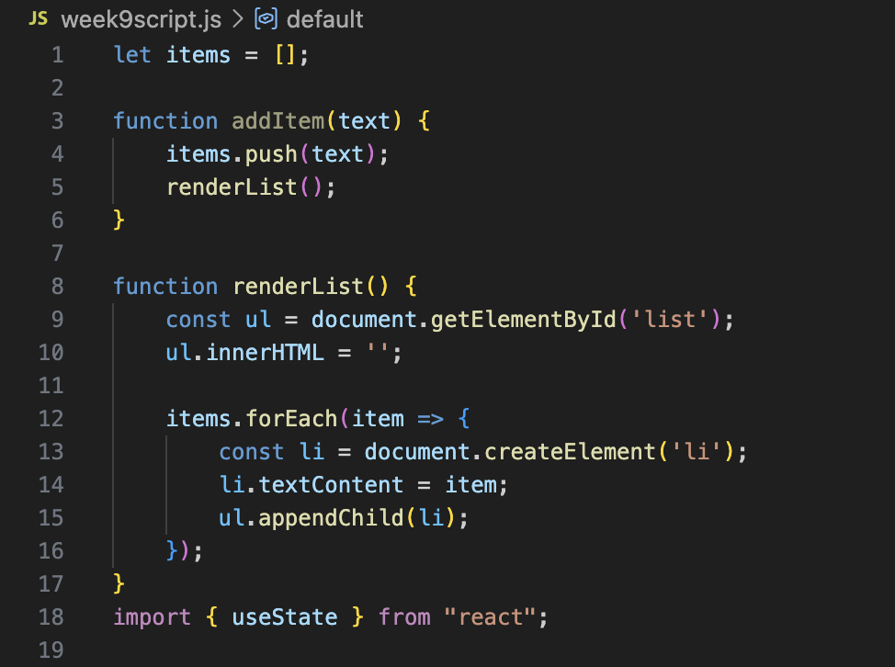

Bonus: Rewrite this as a React component using useState. Use the counter
example from Exercise 9.1 as a template.
